Changes in stream morphology within a 27 year time scale of the Mad River, Humboldt County, California
Suzy Homsombath

Abstract
Changes in stream morphology can occur naturally or can be anthropogenically induced. Natural changes in stream morphology can be caused by the geology of the area as well as stream discharge and sediment load. Rivers are dynamic but rivers strive to maximize energy expenditures (i.e. sinuosity and cutbanks) over the length of its course. Anthropogenic causes to stream morphology include gravel mining, timber/grazing and agriculture. Rivers are strongly influenced by land use and can have detrimental, long-lasting impacts (i.e. legacy impacts). For the current study, we looked at stream morphology that have occurred on the Mad River from 1988-2014. Historic land use such as mining and the logging boom have occurred on the Mad River. Due to the Mad River being important for the people of Humboldt County (i.e. Municipal water and Irrigation) it is important to understand how the river may change. With climate projecting to increase in temperature and decrease in precipitation, we ask how might the Mad River change and what land use types are contributing to that change? We found that the Mad River has actually improved over the 27 year study period (1988-2014). The shape of the river was wider in 1988 suggesting major degradation on the banks of the river while the shape of the river in 2014 was narrower. A "narrow" river suggests flow that did not degrade the river banks. Since the shape of the river narrowed, we can infer that the river may not have had as many high flows (i.e. lack of precipitation throughout the study period). Further research needs to be done to understand how water quality may have changed throughout the study period.

Introduction
Stream channel morphology changes happen naturally but due to land use along a stream gradient, those changes are speeding up. Rivers are strongly influenced by land use of multiple scales through which they flow (Allan 2004). Understanding why the shape of a river may change is important for managers when planning for stream restoration. The shape of the river is driven by the river's attempt to maximize energy such that the energy expenditures (i.e. sinuosity) is balanced over its length (Mount 1995). Certain land uses may interrupt the river’s attempt to come to dynamic equilibrium (Mount 1995). Similar studies have used remote sensing imagery (e.g. aerial and satellite imagery) and a geographic information system (GIS) to analyze morphological changes (Karwan et al. 2001). The stream morphology may happen due to many contributing factors mainly from anthropogenic sources. For the study we will look at land use along the river and possible climate related factors such as drought. In drought years the morphology of the river may change. Although the quality of the water poses a great threat to salmonid survival and regeneration the changes in channel morphology will be the main focus of the study. Detrimental changes in the stream morphology can infer possible impacts to any salmonid habitat or human dwellings on the flood plain. For the current study, we looked at two images: 1) an orthographic image from 1988 and 2) an orthographic image from 2014. Both images were taken during the summer in the month of June. With climate change projecting to have a climate that is drier, hotter and a longer growing season the flow of the river is expected to change even more. In the face of climate change, we ask the question, how does the morphology of the stream change and what factors contribute to those changes? We hypothesize that the morphology of the stream will widen at areas that have indirect impacts from the varying land use types nearest the river and the land use is the main contributing factor indirectly changing the morphology of the river.

Methods

Study Area
The mad river is 113 miles long but the study focused on a 3 mile stretch from Blue Lake to the railway bridge (Figure 1).The Mad River is important such that the towns of Mckinleyville and unincorporated areas, Blue Lake, Arcata and Eureka both depend on the water for municipal purposes (i.e. drinking and irrigating water). Mad River accounts for 65% of the drinking water for Humboldt County’s population (Humboldt Bay Municipal Water District). It is critical that the morphology of the Mad River be sustainable in which salmon and humans may benefit. The Mad River has historically undergone many land use types such as: timber production, agriculture, cattle grazing, urban development and aggregate mining. These types of land use may have indirect negative effects on the morphology as well as quality. Fisheries on the mad is very important due to the endangered species that dwell there, such as the Chinook, Coho salmon, summer and winter-run steelhead, Eulachon and the Longfin smelt (Mad River Alliance).
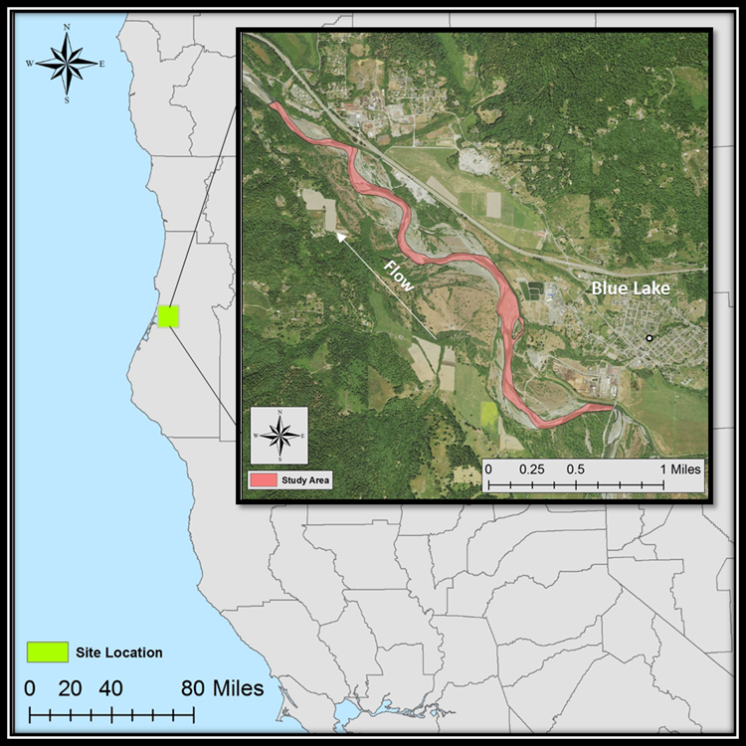
Figure 1. Location of the study area in Blue Lake, Humboldt County, California.
Data acquisition
An image of Humboldt County used for the study was an orthographic photograph made by the National Agriculture Imagery Program (NAIP) from the United States Department of Agriculture's (USDA) Farm Service Agency (FSA) for the year of 2014 taken in June. The image was acquired from the United States Geological Survey (USGS) Geospatial Data Gateway. The pixel size was 1 m by 1m and the pixel depth was 8 bit. The spatial reference for the analysis was the North American Datum Universal 1983 Universal Transverse Mercator Zone 10 North (NAD 83 UTM Zone 10 N) . The ortho image from 1988 was obtained from USGS Earth Explorer GIS data portal. The pixel size was 1 m by 1 m and the pixel depth was 8 bit. Precipitation data was acquired through the National Oceanic and Atmospheric Administration (NOAA) from January 1, 1988 through December 31, 2014. Land use parcels was acquired through the Humboldt Planning and Building Department through their GIS data portal.
Analysis
The shape of the river was digitized by visually estimating the river bank. The river bank was characterized as the point at which large vegetation colonized. There is uncertainty in the digitized river shape due to human error. Although precision was utilized the accuracy may not be on point. A shapefile was digitized for the study years (1988 & 2014). The surface area was calculated using the “calculate geometry” tool in the attribute table for both shapefiles. A geoprocessing tool, “Intersect”, was used to find the areas that were the same. This tool input data from both shapefiles where a new field was created (i.e. percent change).The field calculator was used to find the percent change in surface area (eqn. 1).
$Percent change=\frac{{(Mad River Area}_{1988}-{Mad River Area}_{2014})}{{Mad River Area}_{1988}}*100$ (1)
The precipitation data was analyzed using Microsoft Excel 2013. Land use parcels were queried using the “Select by Attributes” tool. Parcels along the Mad River were selected.

Results
The shape of the river changed 48% since 1988. The surface area of the Mad River in 1988 was 818,384 square meters and the surface area for the Mad River in 2014 was 426,530 square meters. The overall shape of the river in 2014 was narrower suggesting that the shape of the river has improved since 1988 (Figure 2). The precipitation that occurred throughout the study was relatively the same, where 67% of the years were below average suggesting that precipitation has not been increasing (Figure 3). The land use types selected included: grazing/timber, gravel mining and agriculture (Figure 2). Areas that changed dramatically were ocularly estimated and deemed extreme change due to the shape of the river shifting the opposite direction (Figure 2). Land use such as the gravel mining coincidentally was in the area of extreme change as well as the grazing/timber parcels (Figure 2).
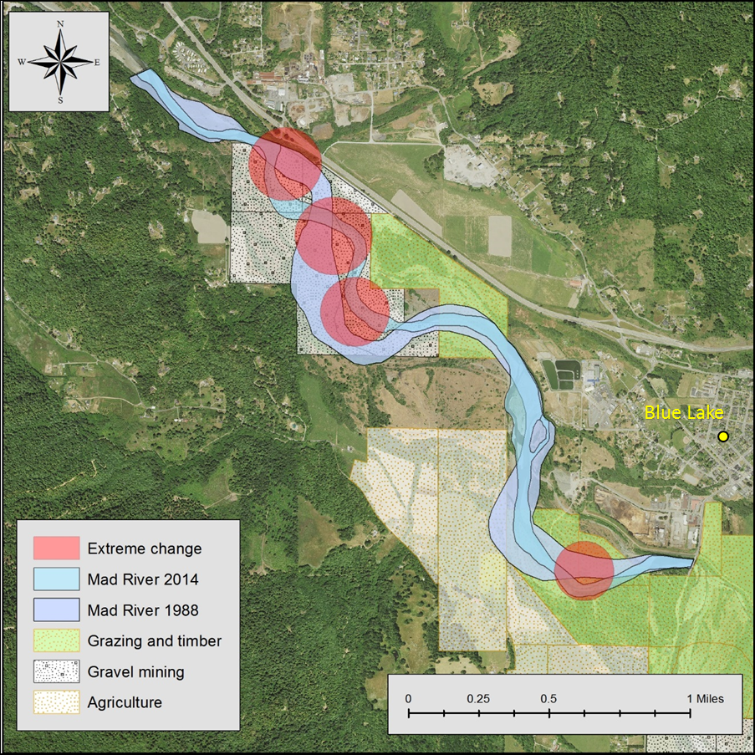
Figure 2. Changes in stream morphology of years 1988 and 2014 showing areas of extreme change and land use types along the Mad River, Humboldt County, California.
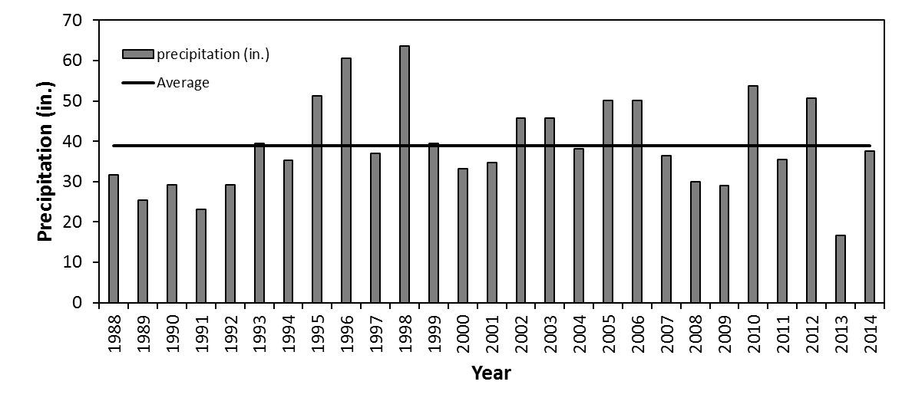
Figure 3. Precipitation (in.) data acquired from National Oceanic Atmospheric Administration (NOAA) from years 1988-2014. Average precipitation was 39 inches.

Discussion
Land use may indirectly affect stream morphology (Mount 1995). Although a lot of non-anthropogenic causes may contribute to changes (i.e. climate, geology of the area, sediment load and stream type) our results show that gravel mining and grazing/timber are affecting the river (Figure 2). The Mad River is a multi-channel river such that the structure of the river is subject to change due to the geology of the area. The multi-channel appears to reflect the river's need to dissipate excess energy (i.e. increased instream flow) and to transport coarse loads (e.g. potential gravel) (Mount 1995). However the gravel mining does contribute to the changes in stream morphology. The river is governed by a "complex feedback system" such that disruptions (i.e. gravel mining) produces changes in river morphology and behavior off-site of the extraction area (Mount 1995). The Blue lake area is considered a wide alluvial valley (Mad River Assessment). The alluvial valley allows the river to have channels that might only occur on high flow days.
The shape of river in 2014 was narrower than the shape of the river in 1988 (Figure 2). The narrowing of the river suggests that watershed planning and assessment efforts have improved the health of the river (Mad River Assessment). According to recent studies on the river, the population of humans have been relatively steady and the increased environmental management and assessments to human impacts have increased (Mad River Assessment). This also includes grazing in the area. There has been no increase in grazing due to the steady population throughout the study period. Gravel mining in the area has improved since the 1990s where gravel mining stakeholders have improved their extraction methods and quantities removed (Mad River Assessment). Wide rivers are usually seen as “degrading” due to fine sediments slowing and settling on to potential salmon habitat. Salmon usually like to spawn in areas that are primarily gravel in order to protect the eggs from predators. Timber management has also improved since the 1990s. Green Diamond Resource Company improved their Habitat Conservation Plan (HCP) in order to comply to the endangerment of the Coho Salmon. These techniques include installation of critical dips over fill crossings to prevent watercourse diversion, inboard ditches were disconnected to direct surface runoff into vegetative buffers. These improvements have improved the river since 1988 but are still contributing to the changes in river morphology (Figure 2).
Our results show that the Mad River has improved since 1988. The morphology is narrower suggesting that mining extraction has been regulated and timber production has improved. Further research needs to be done in assessing the water quality of the Mad River in order to quantify any impacts by the land use types along the river channel.

References
Allan, J. David. "Landscapes and Riverscapes: The influence of land use on stream
Ecosystems." Annual Review of Ecology, Evolution, and Systematics, 35.1
(2004): 257-284.
EarthExplorer. (n.d.). Retrieved May 02, 2016, from http://earthexplorer.usgs.gov/
GIS Data Download | Humboldt County, CA - Official Website. (n.d.). Retrieved May 02,
2016, from http://humboldtgov.org/276/GIS-Data-Download
Karwan, DL, JD Allan, and KM Bergen. “Changing Near-stream Land Use and River
Channel Morphology in the Venezuelan Andes.” Journal of the American Water
Resources Association, 37.6 (2001): 1579-1588.
Mad River Watershed Assessment. 2010. Final Report. Prepared by Stillwater
Sciences, Arcata, California in association with Redwood Community Action Agency, and Natural Resources Management Corp. Eureka, California.
Mount, Jeffrey F. California Rivers and Streams: The conflict between fluvial processes
And land use. University of California Press Berkeley and Los Angeles California. (1995). Print.
"The Mad River." The Mad River Alliance. Mad River Alliance, n.d. Web. <http%3A%2F%2Fwww.madriveralliance.org%2Fthe-mad-river-intro%2F>.
USDA:NRCS:Geospatial Data Gateway:Home. (n.d.). Retrieved May 02, 2016, from
https://gdg.sc.egov.usda.gov/

